Daniel Currently (Monday) writing up draft using desktop Word (not here) – here are the bare bones I’m starting with and using the A1 questions as a guide, should have content up by 5pm (8pm ET). The overview at this point is just paraphrasing/quoting Channon and Adam.

Project Idea

**Overview**

Our Project is a privacy checking app that scans settings in Facebook and other social media platforms to allow the user to be more secure, it has pop-ups to tell them they are not secure and will explain to them what they are sharing and with who and guide them in a process of how to become safe and secure. It will primarily use tutorial video links. The project idea is an app for both Android and iOS, that will evaluate an individual's privacy settings that they have on their various social media accounts, be it Instagram, Facebook, Twitter, or WeChat, with the ability to expand and add more later. The app will work by the user giving permission to access their social media accounts with their login details to allow the app to then check their privacy and security settings. For example, like on Facebook are their posts public, are their Pictures public that they don't need to be besides their profile pictures and then it will make recommendations based on what we found. The app can't directly change any settings (at this point). A lot of the settings for them, so the idea is that will say hey, this is bad. This is bad. This is bad and here are some videos that we can link you to on that we've created on YouTube with a step by step tutorial showing them how to resolve those security issues. It will also push notifications to notify them if their privacy agreements with the social media platforms are changed or update by the provider. So basically, it's going to do a security and privacy checkup.

**Motivation**

The motivation for this app was to empower users of social media to take back control of their online presence and educate them on the security and privacy issues associated with their social media use. Humans are social creatures and the digital era didn’t change this, but it did change the way we communicate. Using social media we have instant access to millions of peoples and we have new ways of interaction. But the social media has security risks. It is used also by criminals for fraud, gathering business intelligence, stealing sensitive information etc (Tayouri 2015). The rise of the social web has traditionally been accompanied by privacy concerns (Netter, Herbst & Pernul 2011). Many people may not be aware of how much information about themselves they are not aware they are sharing online to the public and how secure their various social media accounts are how vulnerable they truly are. How a person has their social media’s security and privacy settings setup makes a substantial difference in determining how much information about them is available to anyone online and how secure their account is in terms of being vulnerable to hacking or other interference or breaches. Because we’re passionate about privacy and security awareness will wanted to put users in control of their social media environment and personal data exposure. We believe this app will be useful in achieving that aim.

**Description**

App

The project is… The features are.... The user will be able to....

Social Media

Another feature….

Security, Privacy and Sharing Settings

There will be a….

Notifications

There will also be a….

Tutorial Videos

Also included will be...

Innovation

The innovation I’d like to see is….

**Tools and Technologies**

The hardware needed to create the project is…. The software we’ll be using is....

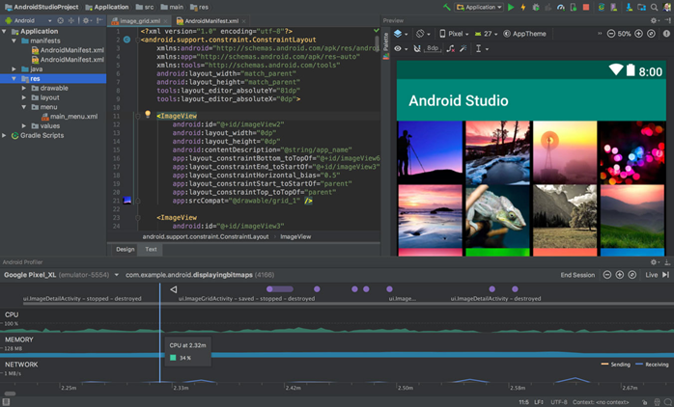

**Skills Required**

The skills required will be/are….. They can be found/learned here…. This project will help us develop our IT skills, experience and knowledge making us more qualified for our ideal jobs than we were before by....

**Outcome**

If this project is successful, the user will have their social media security and privacy settings aligned with their own personal preference and be only sharing what information they deem fit. Users will be confident they can use social media safely and securely knowing their accounts are safe from interference and their data and personal information is secure are protected. Hopefully users will be educated in the risks associated with social media use and the appropriate settings and measures to take place to mitigate those risks, allowing them to enjoy the benefits of social media and avoid the numerous pitfalls. With the app monitoring for changes that social media platforms may make to any security or privacy practices or practices, users will also be protected into the future and have no need to be anxious about any adverse changes going unnoticed. The original problem of poor social media security and privacy will be solved, and user's awareness and education will be improved.

The potential drawbacks are the need to have the app running in the background to allow it to provide notifications about settings changes and the need for the app to be updated periodically. Because the app may not be able to make the settings changes itself and will have to rely on the user successfully following tutorials, human error may mean some changes may not actually take affect but the user will think they have giving them a false sense of security. Or the user may give up making the changes if the task is too laborious or complicated which it sometimes can be when navigating social media security settings - they aren’t always the easiest to locate. Another potential obstacle we anticipate is keeping up with the changes in a timely manner and having new tutorial videos ready. The tutorial videos must also be easy to follow and aimed at novices which will need testing - the videos could seem easy to follow to ourselves who have IT experience, but we may leave some people behind. We will keep this in mind during development to make sure the app is effective. With appropriate measures and safeguards we believe this app has the potential to make a real difference in improving social media security and privacy so it can be used safely and be the enjoyable experience it set out to be without the risk.

References

Netter, M, Herbst, S & Pernul, G 'Analyzing Privacy in Social Networks--An Interdisciplinary Approach', 9-11 Oct. 2011, pp. 1327-1334.

Tayouri, D 2015, 'The Human Factor in the Social Media Security – Combining Education and Technology to Reduce Social Engineering Risks and Damages', *Procedia Manufacturing*, vol. 3, pp. 1096-1100.